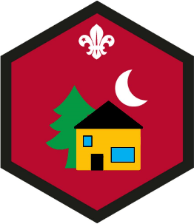
Indoors Challenge Award
- Go on the Sleep-In and do at all of these:
- help put up a tent or build a bedsheet den
- set up your bed and sleeping bag
- help to make your dinner & wash up afterwards
- Learn how to tie three simple knots.
- Show that you:
- know what to do if someone has an accident
- know why it is important to tell an adult when an accident happens
- can do simple first aid for someone who has a cut or bruise
- Take part in an activity using natural things like leaves, bark, twigs, sand or rocks.
- Know how to :
- keep yourself as safe as possible from Covid-19
- Wash your hands properly
- Social Distance
- Go on a Garden Safari,
- Make something to help animals in the wild. It could be a bird box or a bug hotel.

