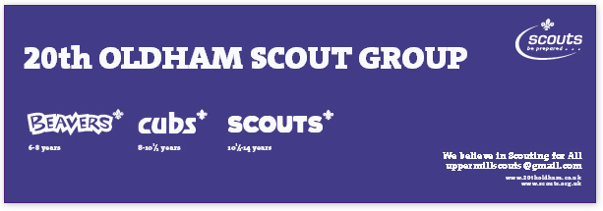
20th Oldham Enquiries: - BEAVERS/CUBS/SCOUTS (please delete as appropriate)

Child’s Details: Name: Date of Birth:
Home Address:

School:

Sibling in another section? Yes / No Attends Uppermill Methodist Church Yes / No

Any Special Needs:

***********************************************************************************
Parent / Carer Details: Name:

Contact number: Email address:

••••••••••••••••••••••••••••••••••••••••••••••••••••••••••••••••••••••••••••••••••••••••••••••••••••••••••••••••••••••
We are always looking for new helpers - would you be prepared to join one of
our sections as an assistant leader? Yes / No

We ask parents to volunteer to help on an occasional basis.
Would you be able to do this? Yes / No

What skills/interests would you be able to offer, to improve the experience of our Scouts?

***********************************************************************************
Enrolling onto the waiting list does not guarantee a place in the 20th Oldham Scout Group.20th Oldham Scout Group is sponsored by Uppermill Methodist Church and members are expected to attend Parade Services.
Parents Declaration
I understand that membership requires commitment and will ensure that my child will attend Scouting activities, Church Parade Services and Parades.

Signed__ Date_

___________________________________________________________________________________

